**SECTION 7.1**

1.

package shapeclass;

public class Shape {

// Instance variables

private int numSides;

private boolean regular;

// Default constructor

public Shape() {

this.numSides = 0; // Default to 0 sides

this.regular = false; // Default to irregular

}

// Parameterized constructor

public Shape(int numSides, boolean regular) {

this.numSides = numSides;

this.regular = regular;

}

// Getter for numSides

public int getNumSides() {

return numSides;

}

// Setter for numSides

public void setNumSides(int numSides) {

this.numSides = numSides;

}

// Getter for regular

public boolean isRegular() {

return regular;

}

// Setter for regular

public void setRegular(boolean regular) {

this.regular = regular;

}

// Example method to display the shape's properties

public void displayShapeInfo() {

System.***out***.println("Number of sides: " + numSides);

System.***out***.println("Is regular: " + regular);

}

// Main method to test the class

public static void main(String[] args) {

// Using default constructor

Shape shape1 = new Shape();

shape1.displayShapeInfo();

// Using parameterized constructor

Shape shape2 = new Shape(4, true);

shape2.displayShapeInfo();

// Modifying the shape using setters

shape1.setNumSides(3);

shape1.setRegular(true);

shape1.displayShapeInfo();

}

}

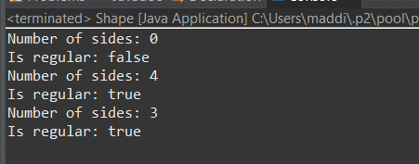

2.

public class Animal {

int weight, height;

double speed;

Animal() {

weight = 50;

height = 4;

speed = 2; //miles per hour

}

Animal(int w, int h, int s ) {

weight = w;

h = height;

speed = s

}

public double getTime(double miles) { //gets the number of hours to go these

miles

return miles/speed;

}

public int getWeight() {

return weight;

}

public int getHeight() {

return height;

}

public double getSpeed() {

return speed;

}

}

JAVA CODE:

package animal;

public class Animal {

int age, legs;

double speed;

// Default constructor

public Animal() {

age = 5;

legs = 4;

speed = 10.0; // meters per second

}

// Parameterized constructor

public Animal(int a, int l, double s) {

age = a;

legs = l;

speed = s;

}

// Method to calculate distance

public double calculateDistance(double time) {

return speed * time;

}

// Getter for age

public int getAge() {

return age;

}

// Getter for legs

public int getLegs() {

return legs;

}

// Getter for speed

public double getSpeed() {

return speed;

}

// Main method to test the class

public static void main(String[] args) {

// Creating an object using the default constructor

Animal animal1 = new Animal();

System.***out***.println("Animal1 Age: " + animal1.getAge());

System.***out***.println("Animal1 Legs: " + animal1.getLegs());

System.***out***.println("Animal1 Speed: " + animal1.getSpeed() + " m/s");

System.***out***.println("Animal1 Distance in 5 seconds: " + animal1.calculateDistance(5) + " meters");

// Creating an object using the parameterized constructor

Animal animal2 = new Animal(3, 2, 20.0);

System.***out***.println("\nAnimal2 Age: " + animal2.getAge());

System.***out***.println("Animal2 Legs: " + animal2.getLegs());

System.***out***.println("Animal2 Speed: " + animal2.getSpeed() + " m/s");

System.***out***.println("Animal2 Distance in 5 seconds: " + animal2.calculateDistance(5) + " meters");

}

}

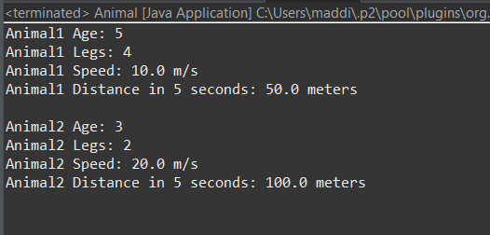

3.

public class Animal {

int age, legs;

double speed;

// Default constructor

public Animal() {

age = 5;

legs = 4;

speed = 10.0; // meters per second

}

// Parameterized constructor

public Animal(int a, int l, double s) {

age = a;

legs = l;

speed = s;

}

// Getter for speed

public double getSpeed() {

return speed;

}

public static void main(String[] args) {

// Creating the first instance using the default constructor

Animal animal1 = new Animal();

// Creating the second instance using the parameterized constructor

Animal animal2 = new Animal(3, 2, 20.0);

// Printing the speeds of both animals

System.***out***.println("Animal #1 has a speed of " + animal1.getSpeed() + ".");

System.***out***.println("Animal #2 has a speed of " + animal2.getSpeed() + ".");

}

}

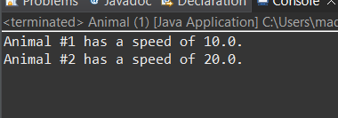

4.

package student;

public class Student {

// Instance variables

private String name;

private int credits;

private double gpa;

private double qualityPoints;

// Constructor

public Student(String name, int credits, double qualityPoints) {

this.name = name;

this.credits = credits;

this.qualityPoints = qualityPoints;

this.gpa = calculateGPA();

}

// Method to calculate the GPA

public double calculateGPA() {

if (credits == 0) {

return 0.0; // To avoid division by zero

}

return qualityPoints / credits;

}

// Method to update credits, quality points, and GPA

public void updateRecord(int newCredits, double newQualityPoints) {

credits += newCredits;

qualityPoints += newQualityPoints;

gpa = calculateGPA(); // Recalculate GPA after updating

}

// Method to return the current GPA

public double getGPA() {

return gpa;

}

// Getter methods for other instance variables (optional)

public String getName() {

return name;

}

public int getCredits() {

return credits;

}

public double getQualityPoints() {

return qualityPoints;

}

// Main method to test the class

public static void main(String[] args) {

// Create a Student object

Student student = new Student("John Doe", 30, 120.0);

// Print initial GPA

System.***out***.println("Initial GPA: " + student.getGPA());

// Update the student's record with new credits and quality points

student.updateRecord(15, 45.0);

// Print updated GPA

System.***out***.println("Updated GPA: " + student.getGPA());

}

}

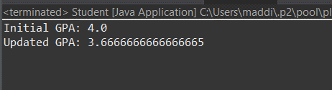

5.

package studentgpa;

public class Student {

// Instance variables

private String name;

private int credits;

private double gpa;

private double qualityPoints;

// Constructor

public Student(String name, int credits, double qualityPoints) {

this.name = name;

this.credits = credits;

this.qualityPoints = qualityPoints;

this.gpa = calculateGPA();

}

// Method to calculate the GPA

public double calculateGPA() {

if (credits == 0) {

return 0.0; // To avoid division by zero

}

return qualityPoints / credits;

}

// Method to update credits, quality points, and GPA

public void updateRecord(int newCredits, double newQualityPoints) {

credits += newCredits;

qualityPoints += newQualityPoints;

gpa = calculateGPA(); // Recalculate GPA after updating

}

// Method to return the current GPA

public double getGPA() {

return gpa;

}

// Getter methods for other instance variables

public String getName() {

return name;

}

public int getCredits() {

return credits;

}

public double getQualityPoints() {

return qualityPoints;

}

// Main method to test the class

public static void main(String[] args) {

// Create three instances of the Student class

Student student1 = new Student("Mary Jones", 14, 46.0);

Student student2 = new Student("John Stiner", 60, 173.0);

Student student3 = new Student("Ari Samala", 31, 69.0);

// Print the details of each student

System.***out***.println(student1.getName() + " has a GPA of " + student1.getGPA());

System.***out***.println(student2.getName() + " has a GPA of " + student2.getGPA());

System.***out***.println(student3.getName() + " has a GPA of " + student3.getGPA());

}

}

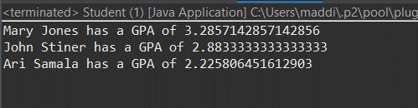

6

package gpa;

public class Student {

// Instance variables

private String name;

private int credits;

private double gpa;

private double qualityPoints;

// Constructor

public Student(String name, int credits, double qualityPoints) {

this.name = name;

this.credits = credits;

this.qualityPoints = qualityPoints;

this.gpa = calculateGPA();

}

// Method to calculate the GPA

public double calculateGPA() {

if (credits == 0) {

return 0.0; // To avoid division by zero

}

return qualityPoints / credits;

}

// Method to update credits, quality points, and GPA

public void updateRecord(int newCredits, double newQualityPoints) {

credits += newCredits;

qualityPoints += newQualityPoints;

gpa = calculateGPA(); // Recalculate GPA after updating

}

// Method to return the current GPA

public double getGPA() {

return gpa;

}

// Getter methods for other instance variables

public String getName() {

return name;

}

public int getCredits() {

return credits;

}

public double getQualityPoints() {

return qualityPoints;

}

// Main method to test the class

public static void main(String[] args) {

// Create three instances of the Student class

Student student1 = new Student("Mary Jones", 14, 46.0);

Student student2 = new Student("John Stiner", 60, 173.0);

Student student3 = new Student("Ari Samala", 31, 69.0);

// Print the initial GPA of Ari Samala

System.***out***.println("Initial GPA of " + student3.getName() + ": " + student3.getGPA());

// Add 13 credits and 52 quality points to Ari Samala's record

student3.updateRecord(13, 52.0);

// Print the updated GPA of Ari Samala

System.***out***.println("Updated GPA of " + student3.getName() + ": " + student3.getGPA());

}

}

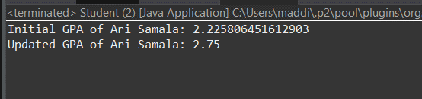

7.

included below:

public class Card{

String suit,name;

int points;

Card(int n1, int n2){

suit = getSuit(n1);

name = getName(n2);

points = getPoints(name);

}

public String toString(){

return "The " + name + " of " + suit;

}

public String getName(int i){

if(i == 1) return "Ace";

if(i == 2) return "Two";

if(i == 3) return "Three";

if(i == 4) return "Four";

if(i == 5) return "Five";

if(i == 6) return "Six";

if(i == 7) return "Seven";

if(i == 8) return "Eight";

if(i == 9) return "Nine";

if(i == 10) return "Ten";

if(i == 11) return "Jack";

Copyright © 2022, Oracle and/or its affiliates. Oracle, Java, and MySQL are registered trademarks of Oracle and/or its affiliates. Other names may be trademarks of their respective owners. 4

if(i == 12) return "Queen";

if(i == 13) return "King";

return "error";

}

public int getPoints(String n){

if(n == "Jack" ||n == "Queen" ||n == "King"||n == "Ten")

return 10;

if(n == "Two")

return 2;

if(n == "Three")

return 3;

if(n == "Four")

return 4;

if(n == "Five")

return 5;

if(n == "Six")

return 6;

if(n == "Seven")

return 7;

if(n == "Eight")

return 8;

if(n == "Nine")

return 9;

if(n == "Ace")

return 1;

return -1;

}

public String getSuit(int i){

if(i == 1) return "Diamonds";

if(i == 2) return "Clubs";

if(i == 3) return "Spades";

if(i == 4) return "Hearts";

return "error";

}

}

public class Main {

public static void main(String args[]){

int suitNumber = (int)(Math.random()*4.0+1);

int faceNumber = (int)(Math.random()*13.0+1);

Card newCard = new Card(suitNumber,faceNumber);

System.out.println(newCard);

}

}

8.

package card;

public class Card {

String suit, name;

int points;

// Constructor

public Card(int suitNumber, int faceNumber) {

suit = getSuit(suitNumber);

name = getName(faceNumber);

points = getPoints(name);

}

// Method to get the string representation of the card

@Override

public String toString() {

return "The " + name + " of " + suit;

}

// Method to get the name of the card based on face number

private String getName(int i) {

switch (i) {

case 1: return "Ace";

case 2: return "Two";

case 3: return "Three";

case 4: return "Four";

case 5: return "Five";

case 6: return "Six";

case 7: return "Seven";

case 8: return "Eight";

case 9: return "Nine";

case 10: return "Ten";

case 11: return "Jack";

case 12: return "Queen";

case 13: return "King";

default: return "error";

}

}

// Method to get the points of the card based on name

private int getPoints(String n) {

switch (n) {

case "Jack":

case "Queen":

case "King":

case "Ten": return 10;

case "Two": return 2;

case "Three": return 3;

case "Four": return 4;

case "Five": return 5;

case "Six": return 6;

case "Seven": return 7;

case "Eight": return 8;

case "Nine": return 9;

case "Ace": return 1;

default: return -1;

}

}

// Method to get the suit of the card based on suit number

private String getSuit(int i) {

switch (i) {

case 1: return "Diamonds";

case 2: return "Clubs";

case 3: return "Spades";

case 4: return "Hearts";

default: return "error";

}

}

}

package card;

public class Main {

public static void main(String[] args) {

// Generate random suit and face numbers

int suitNumber1 = (int) (Math.random() * 4) + 1; // Values between 1 and 4

int faceNumber1 = (int) (Math.random() * 13) + 1; // Values between 1 and 13

int suitNumber2 = (int) (Math.random() * 4) + 1; // Values between 1 and 4

int faceNumber2 = (int) (Math.random() * 13) + 1; // Values between 1 and 13

// Create two random Card instances

Card card1 = new Card(suitNumber1, faceNumber1);

Card card2 = new Card(suitNumber2, faceNumber2);

// Print the details of both cards

System.out.println(card1);

System.out.println(card2);

}

}

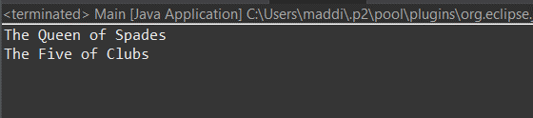

9

package card;

import java.util.ArrayList;

import java.util.Scanner;

public class Main1 {

public static void main(String[] args) {

Scanner scanner = new Scanner(System.***in***);

ArrayList<Card> hand = new ArrayList<>();

int totalPoints = 0;

final int MAX_CARDS = 5;

// Add two random cards to the hand

for (int i = 0; i < 2; i++) {

int suitNumber = (int) (Math.*random*() * 4) + 1; // Values between 1 and 4

int faceNumber = (int) (Math.*random*() * 13) + 1; // Values between 1 and 13

Card card = new Card(suitNumber, faceNumber);

hand.add(card);

totalPoints += card.points;

}

// Display the initial hand

System.***out***.println("Initial hand:");

*displayHand*(hand);

System.***out***.println("Total points: " + totalPoints);

// Loop to add more cards until the conditions are met

while (totalPoints <= 21 && hand.size() < MAX_CARDS) {

System.***out***.println("Would you like another card? (yes/no)");

String response = scanner.nextLine();

if (response.equalsIgnoreCase("yes")) {

int suitNumber = (int) (Math.*random*() * 4) + 1; // Values between 1 and 4

int faceNumber = (int) (Math.*random*() * 13) + 1; // Values between 1 and 13

Card card = new Card(suitNumber, faceNumber);

hand.add(card);

totalPoints += card.points;

// Display the updated hand

System.***out***.println("New card:");

System.***out***.println(card);

System.***out***.println("Updated hand:");

*displayHand*(hand);

System.***out***.println("Total points: " + totalPoints);

if (totalPoints > 21) {

System.***out***.println("You have gone over 21 points!");

break;

}

} else {

break;

}

}

// Close the scanner

scanner.close();

}

// Method to display all cards in the hand

private static void displayHand(ArrayList<Card> hand) {

for (Card card : hand) {

System.***out***.println(card);

}

}

}

